Surgical Wait Times Report

Contents
Overview 1
Purpose and Scope 2
Purpose 2
Rationale 2
Scope 2
Operational Areas Encompassed 2
Methodology 3
Decisions 3
Stratification 3
Timeframe 3
Animals Included 4
Data Visualization 4
Technical Implementation 7
Source Data Updates 8
Current Code Repository 8
Report Generation Logic 8
Data Outputs 9
Excel-based Reporting File 9
Online Summary Dashboard 9
Automation and Operations 9
Scheduled Execution 9
Report Change Log 10

Overview

Purpose and Scope

Purpose
Monitor surgical wait times as a barometer of efficient population flow and management of length of stay (LOS).

Rationale
Tracking surgical wait times allows shelters to identify and manage an important modifiable component of LOS. Surgical bottlenecks can occur for a number of reasons. Creating benchmarks and tracking improvement, or slowdowns, helps to maximize efficiency and minimize unnecessary extra time in the shelter.

Wait times for dental surgery represent a difficult balancing act, given that dentals are time-consuming and that many animals need both spay/neuter surgery and dental extractions. Not all veterinarians are proficient in dentistry, especially more complex procedures such as full-mouth extractions in cats.

Scope
The report summarizes wait times for spay and neuter for dogs, cats and rabbits, and wait times for dental surgeries for dogs and cats.

Operational Areas Encompassed
- Flow through the surgery day
- Support staff – numbers and training
- Surgeon training, speed and skill
- Time available for surgeries
- Scheduling strategies

Methodology

Decisions
Population Scope | Shelter dogs, cats and rabbits.
Stratification | Spay, neuter and dental surgeries.
Inclusion/Exclusion | Excluded animals too young for surgery at admission.
Complexities | - Which stages to use? Initially Stage: Surgery Needed to Stage: Postop; when “surgery needed” not present then use Stage: Evaluate/Intake Date.  - Goal wait times  - Multiple surgeries on the same day

Goal wait times
The initial strategy was to base goal wait times on historical wait times month-by-month, with a built-in desired % improvement. This was too complex and was discarded in favour of target wait times determined by the senior surgical team:
- 7 days for neuter surgery
- 8 days for spay surgery
- 14 days for dental surgery

These goal times are shown on all visualizations, as a rapid comparison with actual times.

The report tabulates the % of all surgery types performed within < 10 days, 10-20 days and > 20 days. As wait times are averages, this helps account for outliers that skew the average.

Stratification
- Species – dogs, cats and rabbits
- Surgery types – spay, neuter and dental – in our procedures list = ovariohysterectomy, orchidectomy, dental COHAT Lvl 1-3, Dental COHAT 4-5, COHAT. (COHAT = Comprehensive Oral Health Assessment and Treatment; level 1 = cleaning, level 5 = full-mouth extractions).

Timeframe
Monthly wait times are calculated.

Animals Included

Included
- Intake types Transfer In, Owner/Guardian Surrender, Stray, and Return.
- Animals with a postoperative stage (Stage: Postop).
- Spay, neuter and dental surgeries.

Not Included
Too young for surgery at time of admission.

Data Visualization

This section provides selected screenshots of reports as they currently appear, to illustrate the output.

The example shows wait times for feline neuter surgeries. The orange line is goal wait time and the blue is actual wait times.

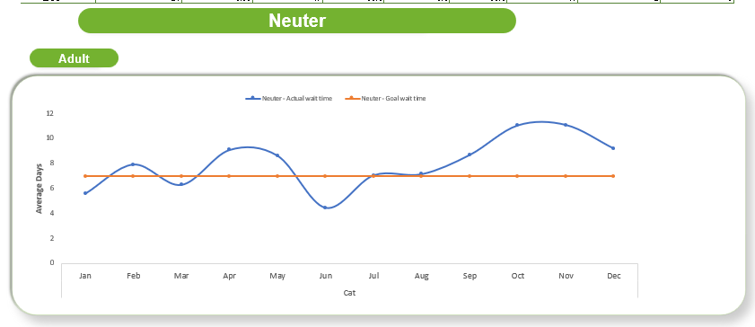

The table provides more detail.

Month | # Surge-ries | Goal | Average | % <=10 days | % 10-20 days | % >20 days | count <10 days | Count 10-20 days | Count >20 days
Jan | 12 | 7 | 6 | 92% | 0% | 8% | 11 | 0 | 1
Feb | 14 | 7 | 8 | 64% | 36% | 0% | 9 | 5 | 0
Mar | 17 | 7 | 6 | 82% | 18% | 0% | 14 | 3 | 0
Apr | 11 | 7 | 9 | 82% | 9% | 9% | 9 | 1 | 1
May | 19 | 7 | 9 | 53% | 42% | 5% | 10 | 8 | 1
Jun | 33 | 7 | 4 | 94% | 6% | 0% | 31 | 2 | 0
Jul | 32 | 7 | 7 | 72% | 25% | 3% | 23 | 8 | 1
Aug | 33 | 7 | 7 | 85% | 6% | 9% | 28 | 2 | 3

This is the rabbit spay report for 2025.

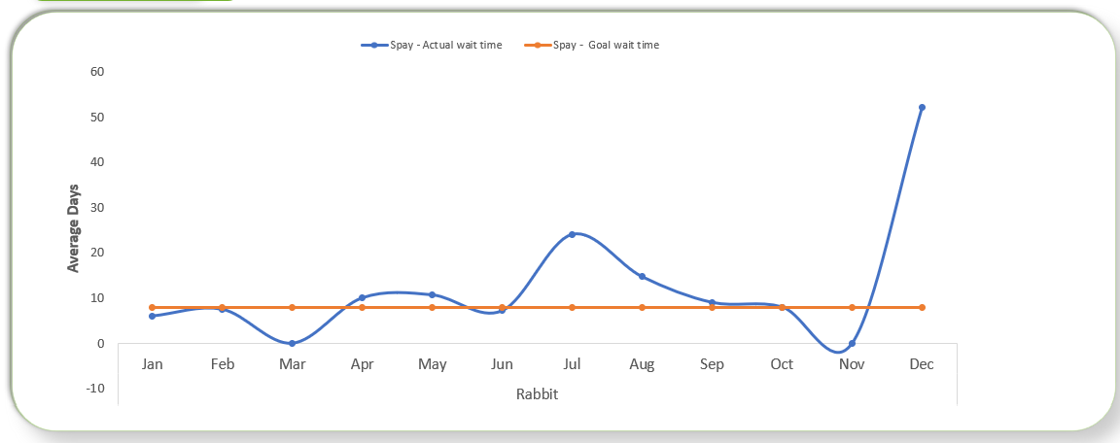

By double-clicking the table provided, the viewer is able to review the outlier value for December.

IntakeDate | SurgeryDate | Stage | SurgeryWait
10/26/2025 | 12/17/2025 | Post -Op | 52

This shows that there was only one rabbit spay in December; a review of the medical record showed that the rabbit required medical care before surgery could be performed.

The image below shows a simplified report, presented in the PowerBI Dashboard for high-level “at a glance” monitoring (see next section).

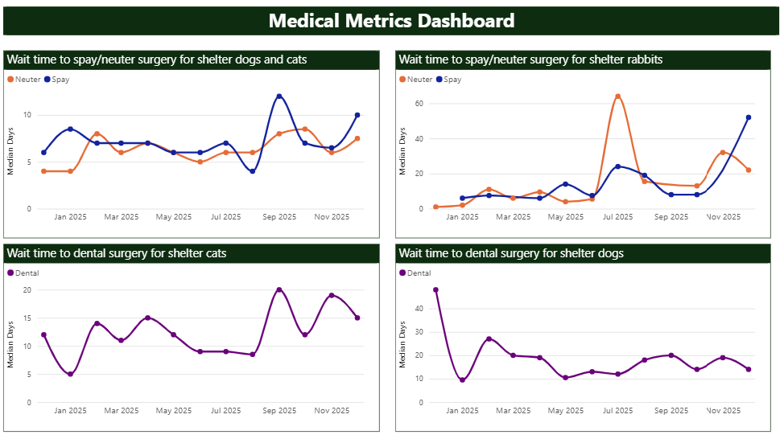

Technical Implementation

The execution script combines Python user-defined functions and SQL queries to extract the report files from a SQL server. By leveraging the capabilities of both Python and SQL, the script facilitates the retrieval and processing of the required data for generating the report files.

Source Data Updates
Source data are received from PetPoint on a recurring monthly basis via an automated file transfer process. The reporting process is designed to run after the monthly data file is received.

Current Code Repository
The current technical implementation for this report is available in GitHub:
THS-Metrics/metric-reports.

Report Generation Logic

Necessary information in the database is pulled into a data sheet using SQL server. Data is stored in tables where animal's records can be associated using unique numbers to create a data sheet with all necessary information associated with that animal in a single downloadable excel sheet. Note that it is important to check that these table connections are associating information correctly.

In the surgical wait time report, there are three significant "Stages" to consider: "Surgery Needed," "Post-op," and “Evaluate”. “Surgery Needed” is the stage entered by the medical staff when the animal is now being considered for surgery. Time prior to this the animal is not added to the surgical list, most frequently due to medical concerns. “Post-Op” is the stage automatically added to a file following the surgery. “Evaluate” is the automated stage entered when an animal enters the shelter.

The report calculates the time difference between Stage:Surgery Needed and Stage:Post-op to determine surgical wait time. In cases where “surgery needed” is not added to the file, “evaluate” is used to determine the surgical wait time.

Another critical cleaning step involves categorizing surgery wait times into intervals (<10 weeks, 10-20 weeks, >20 weeks). For each newly created time interval column, the script assigns a value of 1 if the corresponding condition is met, and 0 if it is not. During the report generation process, the sum of all surgery wait times within each interval can be determined by aggregating the values of 1s and 0s.

Python is used to generate a consolidated data sheet from these sheets. The output is written to an Excel file, which serves as the primary output of the data processing step and as the interface between the automated data extraction and the downstream reporting. Within this Excel file, the data are derived from the consolidated data sheet and saved to a separate worksheet. Storing data within the Excel file allows the data to be reviewed, reused, and linked directly to reporting tools.

Data Outputs

Excel-based Reporting File
The report’s Excel-based reporting file has been predesigned with tables and visualizations, with the data source being the output Excel file generated by the python script. generated by the Python script. Whenever the script is executed, the reporting file refreshes automatically, ensuring that it remains updated with changes in the underlying data.

Online Summary Dashboard
An online summary dashboard presents a simplified view of selected metrics derived from the same underlying data. The dashboard uses PowerBI. It is intended for high-level monitoring “at a glance” and does not expose the full underlying dataset available in the Excel-based reporting file. It is available to all staff in our organization.

Automation and Operations

Scheduled Execution
The reporting process is designed to be run automatically on a scheduled basis. Automation consists of executing the Python reporting script at a defined interval in an environment where required dependencies and credentials are available.

For this report, automation is intended to run once per month. Each execution refreshes the processed output files, which in turn update any downstream reporting or summary views that depend on them. Successful execution can be verified by confirming that output files have been updated for the current reporting period.

Automation may be implemented using any scheduling system capable of running a Python script (e.g. task schedulers, cron jobs, or workflow tools), provided the script is executed in a configured Python environment.

Report Change Log
MMDDYY | Change | Initials

